Scarecrow Competition
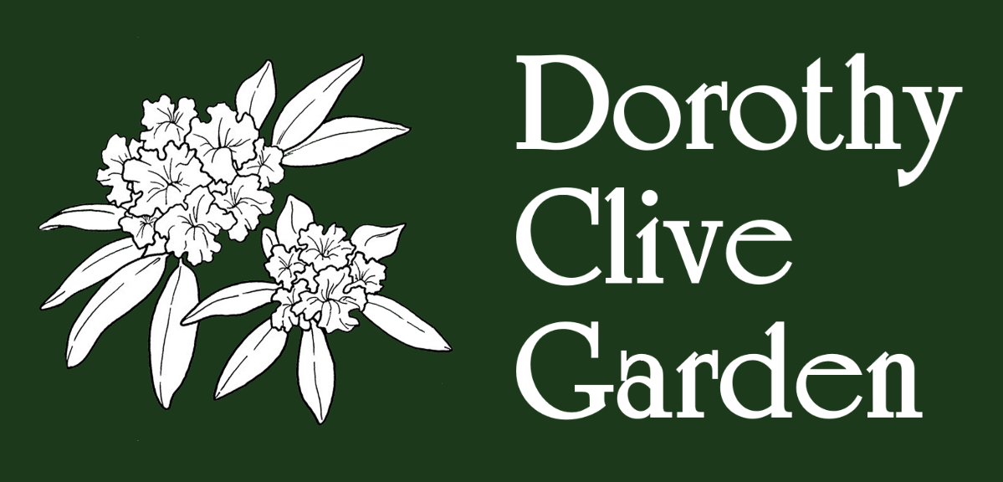
Entry Form
(Rules Overleaf)
PART 1 (to be handed in)
Name / Title of Scarecrow ……………………………………………………………………………………………..
Name of Entrant …………………………………………………………………………………………………………….
Address…………………………………………………………………………………………………………………………..
Contact Number …………………………………………………………………………………………………………….
Email Address ………………………………………………………………………………………………………………..
Category (please circle)
Children - (Under 10) (Over 10) Adult
For children’s categories please provide names and ages of children ……………………………………………………………………………………………………………………………………………………………………………………………………………………………………………………………………………………
Parent Declaration: I confirm that my child / children have permission to enter this category and I take the required responsibilities (as stated in the Rules). I confirm that this entry has been created by my child / children.
Name: …………………………………………………….. Signature: …………………………………………………….
Completed forms must be submitted to the office.
Deadline for entries – Friday 23rd September at the latest.
___________________________________________________________________________
COLLECTION OF SCARECROW AFTER THE EVENT
If you wish to collect your Scarecrow after the event please circle below.
I wish to collect my Scarecrow I do not wish to collect my Scarecrow
___________________________________________________________________________
PART 2 (to be detached and firmly displayed on your Scarecrow)
Name of Scarecrow …………………………………………………………………………………………………………..
Name of Entrant …………………………………………………………………………..Age …………………………….
Scarecrow Competition Rules
The Scarecrow Competition is part of our Autumn / Apple Celebration Event.
Any size of Scarecrow is accepted BIG or small

CATEGORIES
- Children (entry form must state ages and declaration should be signed by parents)
- Individual Adult

HOW TO ENTER
- Scarecrows must be handed into the Garden Office by Friday 23rd September along with a completed entry form.
- PART 2 of the entry form must be displayed on your entry so that the judges can see it.

JUDGING
This will take place on the day of the event Sunday 25th September 2022
The results will be announced at ???? on the Tearoom Lawn
Prizes will be given in all categories.

RULES
- Your Scarecrow must be an original piece of work and made from scratch
- Your Scarecrow must be in good taste and suitable for a family event.
- Your Scarecrow must be able to withstand all weather conditions.
- The Garden does not accept any responsibility for any loss or damage to your scarecrow whilst it is on the premises.
- THE JUDGES DECISIONS ARE FINAL AND NO CORRESPONDENCE WILL BE ENTERED INTO.

Have fun – give your Scarecrow a name and personality!

