The Dorothy Clive Garden invite you to enter an
Apple Cake Baking Competition
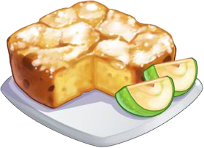

at our Autumn / Apple Celebration Day on Sunday, 25th September 2022

RULES FOR COMPETITION

- All cakes must be covered and received by 12.00pm on Sunday 25th September 2022 and placed on the table located outside the Tearoom.
- All cakes must be marked with the entrants name and age.
- Tasting and Judging will take place at 4.00pm on the Tearoom Lawn by our Head Gardener Zdenek. Prizes will be awarded shortly afterwards.
- The judge’s decision is final.
PRIZES
Prizes will be awarded in the following categories
Adult 18+
Tween (10-17)
Child 9 and under
-----------------------------------------------------------------------------
APPLE CAKE BAKING COMPETITION
Name __________________________________
Adult ( ), Tween 10 to 17 yrs ( ), Child 9 and under ( )
Please display alongside your cake.

